

**PPC Entourage**

**DB Design document**

**Version 1.0**

**22 May 2017**

RECORD OF CHANGE

* A – Added, M – Modified, D - Deleted

|  |  |  |  |  |
| --- | --- | --- | --- | --- |
| **Date** | **Changed Items** | **\*A, M, D** | **Description** | **Version** |
| 22-May-2017 |  | A | Create first version | 1.0 |
| 23-May-2017 |  | M | Update diagrams | 1.0 |

# **DB Diagram**

1. Main functions

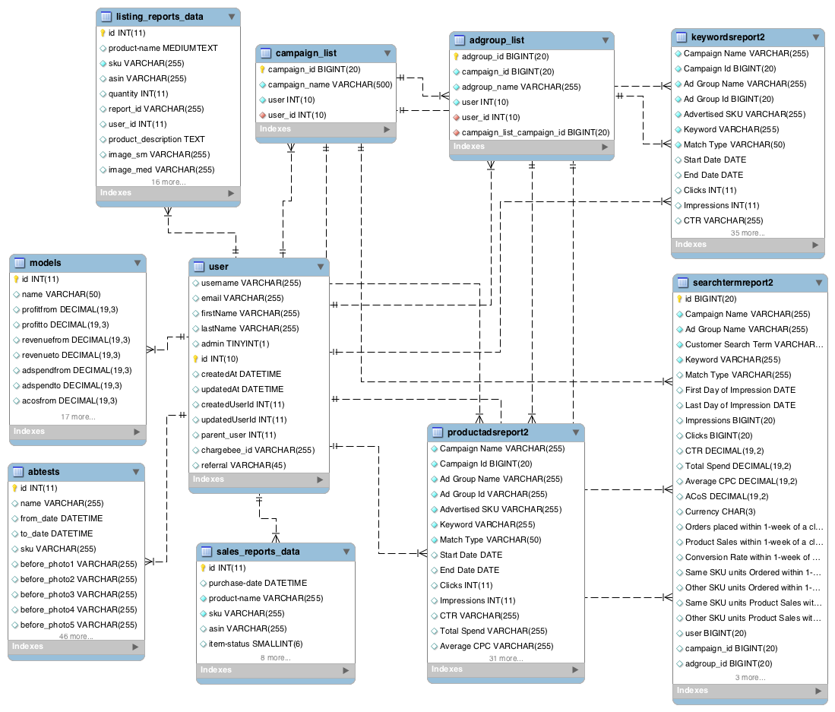

2. User management

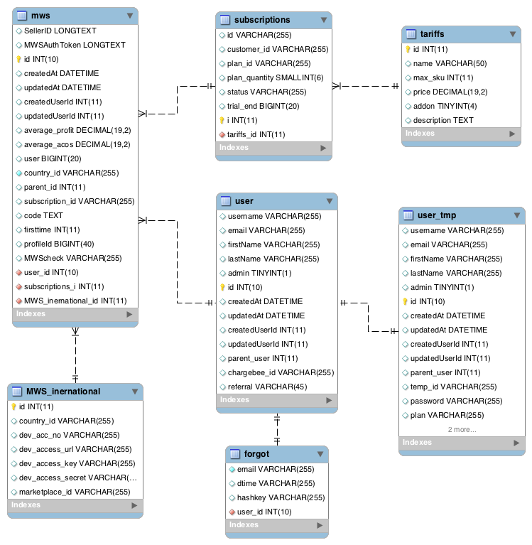

3. Robot functions

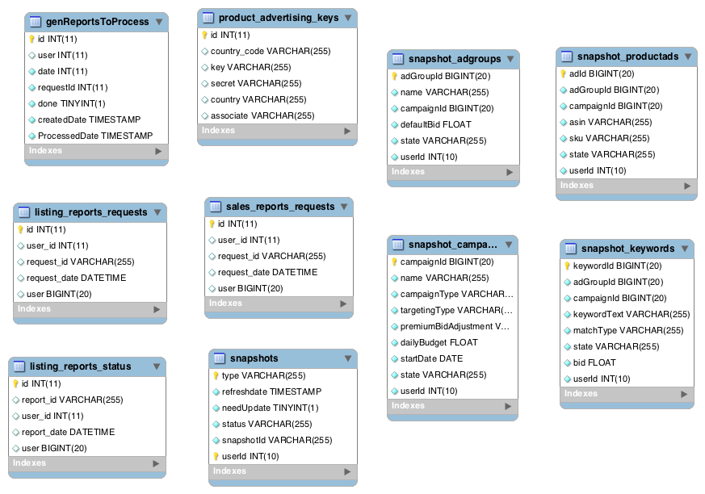

4. Other functions

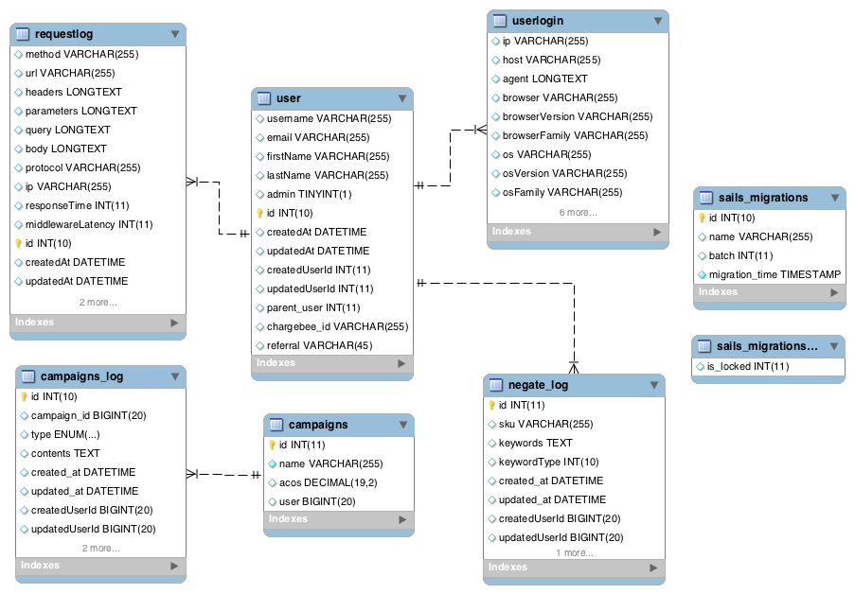

# **DB Description**

This is description for all current tables.

|  |  |  |
| --- | --- | --- |
| **No** | **Table name** | **Note** |
| 1 | abtests | ??? (ask Adel) |
| 2 | adgroup_amazon | Using for robot(*will be renamed after fixing done*) |
| 3 | adgroups_names | delete |
| 4 | all_adgroup_name | Only use for IDs fixing, delete after done |
| 5 | all_campaign_name | Only use for IDs fixing, delete after done |
| 6 | author | Delete |
| 7 | book | Delete |
| 8 | campaign_amazon | Using for robot(*will be renamed after fixing done*) |
| 9 | campaign_names | Delete |
| 10 | campaignperfomancereport | Delete |
| 11 | campaignperfomancereport_copy | Delete |
| 12 | campaigns | ??? => ask Adel |
| 13 | campaigns_log | Track campaign information |
| 14 | customer_entity | Delete |
| 15 | file | Delete |
| 16 | forgot | Store forgot password token |
| 17 | genReportsToProcess | Store queue of report for process by robot |
| 18 | home | Delete |
| 19 | keywords_names | Delete |
| 20 | keywordsreport2 | Store all user’s keyword info |
| 21 | keywordsreport2_backup | Only use for IDs fixing, delete after done? |
| 22 | keywordsreport2_backup_2 | Only use for IDs fixing, delete after done? |
| 23 | listing_reports_data | Store report data of product: price, total shipping cost, cost per unit, …. |
| 24 | listing_reports_data_copy | Delete |
| 25 | listing_reports_requests | Store queue of product report for process by robot |
| 26 | listing_reports_status | Delete |
| 27 | message | Delete |
| 28 | models | Store params filter by user for reuse |
| 29 | mws | Store Amazon seller info of user |
| 30 | mws_cancelled | Delete |
| 31 | MWS_inernational | Store Amazon dev account based on country |
| 32 | negate_log | ???=> ask Adel |
| 33 | passport | Store login info of user |
| 34 | product | Delete |
| 35 | product_advertising_keys | Store advertising keys for AMZ Marketplace Web service |
| 36 | productadsreport2 | Store product ads info |
| 37 | productadsreport2_backup | Only use for IDs fixing, delete after done? |
| 38 | productadsreport2_backup_2 | Only use for IDs fixing, delete after done? |
| 39 | requestlog | Store log of every user request |
| 40 | sails_migrations | For migrations database of Sails framework |
| 41 | sails_migrations_lock | For migrations database of Sails framework |
| 42 | sales_reports_data | Store sale info of product: Order id, purchase date, price, quantity, Asin, ….. |
| 43 | sales_reports_data_backup | Only use for IDs fixing, delete after done? |
| 44 | sales_reports_requests | Store queue of sale report for process by robot |
| 45 | sales_reports_status | Delete |
| 46 | Searchtermreport | Delete |
| 47 | searchtermreport_copy | Delete |
| 48 | searchtermreport2 | Store user search term report: number of impressions, click of each ads group on each search term |
| 49 | searchtermreport2_num | Delete |
| 50 | searchtermreport2_old | Delete |
| 51 | searchtermreport2_temp | Only use for IDs fixing, delete after done? |
| 52 | searchtermreport2_temp_v2 | Only use for IDs fixing, delete after done? |
| 53 | searchtermreport2_v1_test | Only use for IDs fixing, delete after done? |
| 54 | searchtermreport2_v2_test | Only use for IDs fixing, delete after done? |
| 55 | searchtermreport2_v3_test | Only use for IDs fixing, delete after done? |
| 56 | searchtermreport2_v4_test | Only use for IDs fixing, delete after done? |
| 57 | searchtermreport3 | Delete |
| 58 | settings | Delete |
| 59 | sku_data | Delete |
| 60 | snapshot_adgroups | Store Amazon Snapshot about Campaigns |
| 61 | snapshot_campaigns | Store Amazon Snapshot about AdGroups |
| 62 | snapshot_keywords | Store Amazon Snapshot about Keywords |
| 63 | snapshot_productads | Store Amazon Snapshot about ProductAds |
| 64 | snapshots | Store Amazon Snapshot about Campaigns, AdGroups, ProductAds, Keywords, for robot |
| 65 | subscriptions | Store user subscriptions |
| 66 | table1 | Delete |
| 67 | table2 | Delete |
| 68 | table3 | Delete |
| 69 | tariffs | Store max_sku, price, … for user subscriptions |
| 70 | user | Store user |
| 71 | user_setting | Delete |
| 72 | user_tmp | Store temp user before verify chagrebee |
| 73 | Userlogin | Log user info: IP, browser, OS, … |

**IV. Other’s ideas**

**Here is Adel’s idea:**

1. Please make sure to remove all tables that are no longer used. Check if the following tables are used in our system and if not, please inform us and let's get rid of them (please let us know the list of tables, before removing them from database):

|  |  |  |  |
| --- | --- | --- | --- |
| **Index** | **Can Delete** | **Using for robot** | **Only use for IDs fixing, delete after done** |
| **1** | user_setting | adgroup_amazon (will be renamed after fixing done) | all_campaign_name |
| **2** | table3 | campaign_amazon (will be renamed after fixing done) | keywordsreport2_backup |
| **3** | table2 | product_advertising_keys | keywordsreport2_backup_2 |
| **4** | table1 |  | productadsreport2_backup |
| **5** | sku_data |  | productadsreport2_backup_2 |
| **6** | settings |  | sales_reports_data_backup |
| **7** | searchtermreport3 |  | searchtermreport2_v1 |
| **8** | searchtermreport2_old |  |  |
| **9** | searchtermreport2_num |  |  |
| **10** | searchtermreport_copy |  |  |
| **11** | searchtermreport |  |  |
| **12** | product |  |  |
| **13** | mws_cancelled |  |  |
| **14** | message |  |  |
| **15** | listing_reports_data_copy |  |  |
| **16** | keywords_names |  |  |
| **17** | home |  |  |
| **18** | file |  |  |
| **19** | customer_entity |  |  |
| **20** | campaignperformancereport_copy |  |  |
| **21** | campaignperformancereport |  |  |
| **22** | campaign_names |  |  |
| **23** | book |  |  |
| **24** | author |  |  |
| **25** | adgroup_names |  |  |
| **Total** | **25** | **3** | **7** |

2. Please create tables for campaigns and ad groups and store campaign/ad group IDs and names. In other tables, instead of storing campaign and ad group names, save IDs (only).

**=> Created two tables: campaign_list and adgroup_list**

3. In the 'campaigns' table, we need to save IDs, not names.

**=> We created table campaign_list for containing all the user’s campaigns. Why do you need this table and for which purpose?**

4. Check whether we need to save historical data in the **'genReportsToProcess'**, **'listing**_**reports**_**requests'**, and **'sales**_**reports**_**requests'** tables.

**=> Yes. We need these.**

5. Determine whether there is any benefit to use database to store dev account credentials (**mws_international** table), instead of using **config.json** or config.js files.

**=> Keep it as it is not needed to change.**

6. Check if we are using data gathered in **requestlog** table and whether we can save recent data only (say, the last 30 days or even 1 week).

**=> We should use a daily robot to clean up the trash data. This idea was created in Rally’s backlog #US171.**

7. Save recent data only in **userlogin** table.

**=> We should use a daily robot to clean up the trash data. This idea was created in Rally’s backlog #US172.**